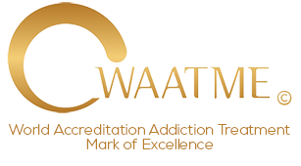

DECLARATION

This declaration is made by:

Name of individual or Company(s):

I Declare, to World Accreditation Addiction Treatment Mark of Excellence © that as an an Addiction Treatment Provider acting as an individual, sole proprietor or business owned entity that I am NOT funded, owned or influenced by a pharmaceutical corporation(s).

This Declaration is executed within the United States, its territories, possessions, or commonwealths:
“I declare (or certify, verify or state) under penalty of perjury that the foregoing is true and correct.”

Executed on this Date:

Signature:

Printed Name:

