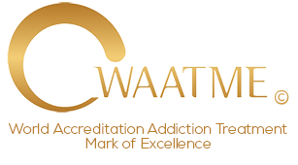

DECLARATION

This declaration is made by:

Name of individual or Company(s):

I Declare, to World Accreditation Addiction Treatment Mark of Excellence © that as an an Addiction Treatment Provider acting as an individual, sole proprietor or business owned entity that I am NOT funded, owned or influenced by a pharmaceutical corporation(s).

Executed without the United States: “I declare (or certify, verify, or state) under penalty of perjury under the laws of the United States of America that the foregoing is true and correct.”

Executed on this Date:

Signature:

Printed Name:

